St. Bartholomew’s Episcopal Church
December 24, 2021
Christmas Eve-10:00 pm

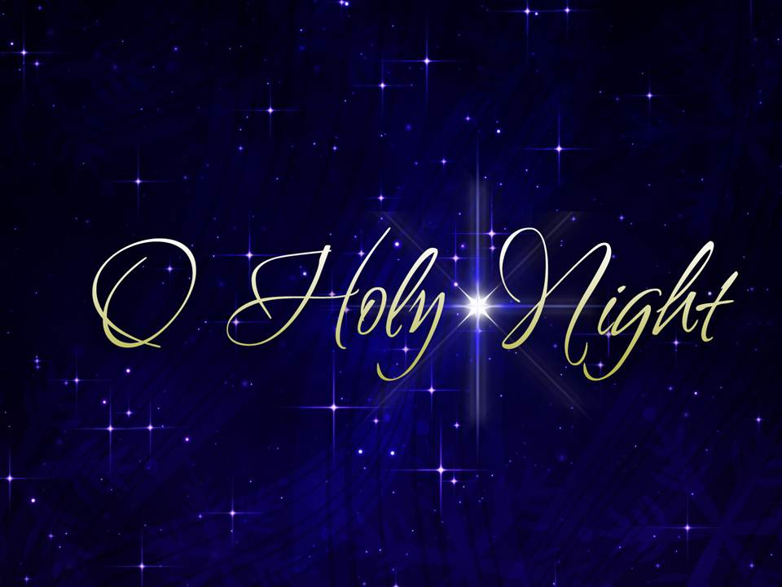

Prelude It came upon the midnight clear....Arr. V. Roubos
Welcome Behold, I bring you good news of a great joy, which will come to all the people; for unto you is born this day in the city of David, a Savior, who is Christ the Lord. Luke 2:10, 11
Almighty God, to you all hearts are open, all desires known, and from you no secrets are hid: Cleanse the thoughts of our hearts by the inspiration of your Holy Spirit, that we may perfectly love you, and worthily magnify your holy Name; through Christ our Lord. Amen.

Call to Worship
Glory to God in the highest,
and peace to his people on earth.
Lord God, heavenly King,
almighty God and Father,
we worship you, we give you thanks,
we praise you for your glory.
Lord Jesus Christ, only Son of the Father,
Lord God, Lamb of God,
you take away the sin of the world:
have mercy on us;
you are seated at the right hand of the Father:
receive our prayer.
For you alone are the Holy One,
you alone are the Lord,
you alone are the Most High,
Jesus Christ, with the Holy Spirit,
in the glory of God the Father. Amen.

Collect of the Day.
O God, you have caused this holy night to shine with the brightness of the true Light: Grant that we, who have known the mystery of that Light on earth, may also enjoy him perfectly in heaven; where with you and the Holy Spirit he lives and reigns, one God, in glory everlasting. Amen.
Isaiah 52:1-9
Awake, awake, put on your strength, O Zion! Put on your beautiful garments, O Jerusalem, the holy city; for the uncircumcised and the unclean shall enter you no more. ²Shake yourself from the dust, rise up, O captive Jerusalem; loose the bonds from your neck, O captive daughter Zion! ³For thus says the Lord: You were sold for nothing, and you shall be redeemed without money. ⁴For thus says the Lord God: Long ago, my people went down into Egypt to reside there as aliens; the Assyrian, too, has oppressed them without cause. ⁵Now therefore what am I doing here, says the Lord, seeing that my people are taken away without cause? Their rulers howl, says the Lord, and continually, all day long, my name is despised. ⁶Therefore my people shall know my name; therefore in that day they shall know that it is I who speak; here am I.
⁷How beautiful upon the mountains are the feet of the messenger who announces peace, who brings good news, who announces salvation, who says to Zion, “Your God reigns.” ⁸Listen! Your sentinels lift up their voices, together they sing for joy; for in plain sight they see the return of the Lord to Zion. ⁹Break forth together into singing, you ruins of Jerusalem; for the Lord has comforted his people, he has redeemed Jerusalem.
Psalm 98
¹O sing to the Lord a new song, for he has done marvelous things. His right hand and his holy arm have gotten him victory.
²The Lord has made known his victory; he has revealed his vindication in the sight of the nations.
³He has remembered his steadfast love and faithfulness to the house of Israel. All the ends of the earth have seen the victory of our God.
⁴Make a joyful noise to the Lord, all the earth; break forth into joyous song and sing praises.
⁵Sing praises to the Lord with the lyre, with the lyre and the sound of melody.
⁶With trumpets and the sound of the horn make a joyful noise before the King, the Lord.
⁷Let the sea roar, and all that fills it; the world and those who live in it.
⁸Let the floods clap their hands; let the hills sing together for joy
⁹at the presence of the Lord, for he is coming to judge the earth. He will judge the world with righteousness, and the peoples with equity.
Hebrews 1:1-9
Long ago God spoke to our ancestors in many and various ways by the prophets, ²but in these last days he has spoken to us by a Son, whom he appointed heir of all things, through whom he also created the worlds. ³He is the reflection of God’s glory and the exact imprint of God’s very being, and he sustains all things by his powerful word. When he had made purification for sins, he sat down at the right hand of the Majesty on high,
⁴having become as much superior to angels as the name he has inherited is more excellent than theirs. ⁵For to which of the angels did God ever say, “You are my Son; today I have begotten you”? Or again, “I will be his Father, and he will be my Son”? ⁶And again, when he brings the firstborn into the world, he says, “Let all God’s angels worship him.” ⁷Of the angels he says, “He makes his angels winds, and his servants flames of fire.” ⁸But of the Son he says, “Your throne, O God, is forever and ever, and the righteous scepter is the scepter of your kingdom. ⁹You have loved righteousness and hated wickedness; therefore God, your God, has anointed you with the oil of gladness beyond your companions.”
The Gospel According to Luke 2:1-14
In those days a decree went out from Emperor Augustus that all the world should be registered. ²This was the first registration and was taken while Quirinius was governor of Syria. ³All went to their own towns to be registered. ⁴Joseph also went from the town of Nazareth in Galilee to Judea, to the city of David called Bethlehem, because he was descended from the house and family of David. ⁵He went to be registered with Mary, to whom he was engaged and who was expecting a child. ⁶While they were there, the time came for her to deliver her child. ⁷And she gave birth to her firstborn son and wrapped him in bands of cloth, and laid him in a manger, because there was no place for them in the inn.
⁸In that region there were shepherds living in the fields, keeping watch over their flock by night. ⁹Then an angel of the Lord stood before them, and the glory of the Lord shone around them, and they were terrified. ¹⁰But the angel said to them, “Do not be afraid; for see—I am bringing you good news of great joy for all the people: ¹¹to you is born this day in the city of David a Savior, who is the Messiah, the Lord. ¹²This will be a sign for you: you will find a child wrapped in bands of cloth and lying in a manger.” ¹³And suddenly there was with the angel a multitude of the heavenly host, praising God and saying, ¹⁴“Glory to God in the highest heaven, and on earth peace among those whom he favors!”
The Sermon Rev. Cathie
Reflection Music O Holy Night( In the style of F. Schubert) ...Arr. C. Klose / A. Adam Soon Yeon Chung
The Nicene Creed
We believe in one God,
the Father, the Almighty,
maker of heaven and earth,
of all that is, seen and unseen.
We believe in one Lord, Jesus Christ,
the only Son of God,
eternally begotten of the Father,
God from God, Light from Light,
true God from true God,
begotten, not made,
of one Being with the Father.
Through him all things were made.
For us and for our salvation
he came down from heaven:
by the power of the Holy Spirit
he became incarnate from the Virgin Mary,
and was made man.
For our sake he was crucified under Pontius Pilate;
he suffered death and was buried.
On the third day he rose again
in accordance with the Scriptures;
he ascended into heaven
and is seated at the right hand of the Father.
He will come again in glory to judge the living and the dead,
and his kingdom will have no end.
We believe in the Holy Spirit, the Lord, the giver of life,
who proceeds from the Father and the Son.
With the Father and the Son he is worshiped and glorified.
He has spoken through the Prophets.
We believe in one holy catholic and apostolic Church.
We acknowledge one baptism for the forgiveness of sins.
We look for the resurrection of the dead,
and the life of the world to come. Amen.

The Prayers of the People The Episcopal Church Adapted from Litany 6
In peace, we pray to you, Lord God.
Rejoicing in the love of God that has come among us in Jesus Christ, let us confidently bring to the Lord the petitions of our heart this Christmas night, saying: Lord hear Our prayer.
For your children throughout the world, especially those in positions of leadership, that they might always work to give glory to God and to bring peace to our earth. Let us pray to the Lord.
Lord hear our prayer.
For the church gathered in this place, that we might see God’s living presence in our world and in our live, finding the nourishment we need to walk as God called and Jesus taught us to do. Let us pray to the Lord. Lord hear our prayer.
As we rejoice in the coming of Jesus our Lord and Savior, we pray that the Church may be continually reborn We pray for our Presiding Bishop Michael, our Diocesan Bishop Caryle, and for all Bishop’s and other ministers, Lay and Ordained. Help us share the humility of the manger, the adoration of the shepherds, and the love of the Holy Family. Let us pray to the Lord.
Lord hear our prayer.
Restore to new life the places in this world that suffer from conflict and are deaf to the message of peace … Bring harmony where there is strife between nations and where people are divided by suspicion and bitterness Let us pray to the Lord.
Lord hear our prayer.
Lord, we lift up in prayer those that we hold in our hearts. We trust Lord that you will act in their lives … Bless the homes where there is sickness or any other trouble. Bring healing to all who are ill or in pain … Give peace to all unquiet minds and troubled spirits. Guide and guard our families and all others with whom we share our lives. We pray for the sick and the dying among us, and for those who care for them, that the God whose love extends from the wood of the manger to the wood of the cross might bless them this night with the gift of peace. Let us pray to the Lord.
Lord hear our prayer.
For all who inspire us by their lives of service. We pray especially for the essential workers, those in health care and research. We pray for our teachers. We pray for the first responders, members of our military and their families. Let us pray to the Lord.
Lord hear our prayer.
We pray for all who have died. On the last day gather us all into your loving arms and heavenly home. Let us pray to the Lord.
Lord hear our prayer.
All loving and gracious God, we thank you for the gift of your presence. Confident of your continuing love for us, we have offered our prayers and requests to you. Hear us Lord and may you answer our prayers through that same Christ, whose birth we remember this night, our Lord and Savior, forever and ever. Amen.

CONFESSION
Celebrant Let us confess our sins against God, our neighbors and ourselves.
People Most merciful God, we confess that we have sinned against you in thought, word, and deed, by what we have done, and by what we have left undone.
We have not loved you with our whole heart; we have not loved our neighbors as ourselves. We are truly sorry and we humbly repent. For the sake of your Son Jesus Christ, have mercy on us and forgive us; that we may delight in your will, and walk in your ways, to the glory of your Name. Amen.
Celebrant Almighty God have mercy on you, forgive you all your sins through our Lord Jesus Christ, strengthen you in all goodness, and by the power of the Holy Spirit keep you in eternal life. Amen.

The Lord’s Prayer
Our Father, who art in heaven,
hallowed be thy Name,
thy kingdom come, thy will be done,
on earth as it is in heaven.
Give us this day our daily bread.
And forgive us our trespasses,
as we forgive those who trespass against us.
And lead us not into temptation but deliver us from evil.
For thine is the kingdom, and the power, and the glory, for ever and ever. Amen.
Silent Night.
THE BLESSING
Celebrant Go in peace; love and care for one another in the name of Christ; and may the Spirit of God which filled John and Jesus, fill your hearts, souls and minds; may the power of God which upheld them, strengthen you for each day; and may the love of God which directed their every action be your guiding light and your shining star, both now and forevermore Amen
Dismissal Go in peace to Love and Serve the Lord. Thanks be to God. Alleluia! Alleluia! Alleluia!

Celebrant-Rev. Cathie Sklenar-Studwell
Music Director-Soon Yeon Chung
Video Director-Kathy Gabrielle
www.stbartshhk.org
201-444-5025
https://www.facebook.com/70Sheridan
https://www.instagram.com/stbartshhk
St. Bartholomew's YouTube
To watch on Facebook, go to the church Facebook page, Like it and Follow It.

To watch on YouTube, go to the church YouTube channel, and subscribe.

St. Bartholomew’s Episcopal Church
Whether In-Person or On-Line
You Are Welcome Here…
Worship Schedule

December 25 10am Christmas Day
Worship in-person, Zoom, Facebook Live, YouTube

December 26 10am
Worship in-person, Zoom, Facebook Live, YouTube

Prayer List-December 24, 2021
Kindly keep the following parishioners and friends
in your prayers this week:
Michelle, Virginia, Joan, Allan, Audrey, Allen, Peter, Peggy, Choi, Fred, Ron, Jim, Evelyn, Jimmy, Sherry, Dic, Rich, Grace, Becky, Jeffrey, Vern, Joan, John, Kathy, Joan, Rakesh, Pam, Danielle, Danny, Oliver, Brigida, Betty, Wayne, JoAnn, Heather, Beth, Joni, Jennifer, Rue, Edith, Barbara, Carolyn, Richard, Beverley, Ed, Marcia, Mehgan, Sylvia, Ben, Diane

For our nation that we may heal and join together.
For our President, Vice President, and all Elected Officials.

For all families suffering from the loss of a loved one.
Prayers for those who are grieving the loss of over five million people globally, and over eight hundred ten thousand Americans who have perished due to COVID19.

We pray for those suffering in our country and around the world. We pray for those impacted by the tornados in the mid-west, and for those in Haiti, Afghanistan, and those impacted by Hurricane Ida

For Wounded Warriors, All Medical Professionals, First Responders, Educators
Grocery Store Workers, Delivery People, and Everyone working to help our country.

Our Wardens, Vestry, Journey Forward Team, All Ministry Teams all Parish members needing prayer.

Please remember in your prayers the friends and families of our parishioners and neighbors who are serving in the military:
Bobby, USA Jennifer, USA, Nicholas, USMC, Miles, USA

For a Birthday
O God, our times are in your hand: Look with favor, we pray, on your servant _____ as he/she begins another year. Grant that he/she may grow in wisdom and grace and strengthen his/her trust in your goodness all the days of his/her life, through Jesus Christ our Lord. Amen.
For an Anniversary
O God, you have so consecrated the covenant of marriage that in it is represented the spiritual unity between Christ and his Church: Send therefore your blessing upon these your servants, that they may so love, honor, and cherish each other in faithfulness and patience, in wisdom and true godliness, that their home may be a haven of blessing and peace; through Jesus Christ our Lord, who lives and reigns with you and the Holy Spirit, one God, now and forever. Amen.
.

